Quote | Key Word | Image | Ideas/explanation | Theme/issue | Context
“and I speak as a hard-headed  business man” (Act 1) [Arthur] | hard-headed | 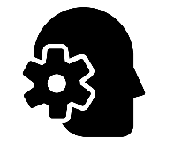
"unsinkable, absolutely unsinkable" (Act I)  [Arthur] | unsinkable
“as if we were all mixed up together like  bees in a hive-community and all that  nonsense” (Act 1) [Arthur] | bees
“it’s better to ask for the  earth than take it” (Act 1) [Inspector] | earth
"“but these girls aren’t cheap  labour. They’re people”. (Act I) [Sheila] | girls
“I felt rotten at the time and now I feel a lot worse” (Act 1) [Sheila] | rotten | 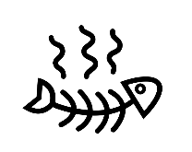
“I know I’m to blame and I’m desperately sorry” (Act 2) [Sheila] | blame
“We often do on the young ones.  They’re more impressionable.” (Act 2) [Inspector] | impressionable
“Girls of that class” (Act 2) [Sybil] | class
“I didn’t feel about her as she felt about me” (Act 2) [Gerald Croft] | felt

Quote | Key Word | Image | Ideas/explanation | Theme/issue | Context
“I didn’t like her manner, she’d impertinently made use of our name”  (Act 2) [Sybil Birling] | name
“I did nothing I’m ashamed of”  (Act 2) [Sybil Birling] | ashamed
“I blame the young man”  (Act 2) [Sybil Birling] | young
“No hushing up, eh?”  (Act 2) [Inspector] | hushing
“You’re not the kind of father a chap  can go to when he’s in trouble” (Act 3)  [Eric Birling] | father
“millions and millions and millions of Eva  Smiths and John Smiths left with us” (Act 3) [Inspector] | millions
“We are members of one body” (Act 3) [Inspector] | body
“the time will soon come when if man won’t  learn that lesson he will be taught it in fire,  blood and anguish” (Act 3) [Inspector] | blood
“You’re beginning to pretend as if nothing’s really happened at all” (Act 3) [Eric] | nothing
“It frightens me the way you talk” (Act 3) [Sheila] | frightens

