Poem & Poet  Power & Conflict Set 1 – Conflict Key Quotes Dual Coded | Quote | Key Words | Image | Interpretations/significant connotations | Themes | Comparison
 | ‘Into the jaws of Death/Into the mouth of Hell’ | hell
 | ‘Half a league, half a league, half a league onward’ | league | 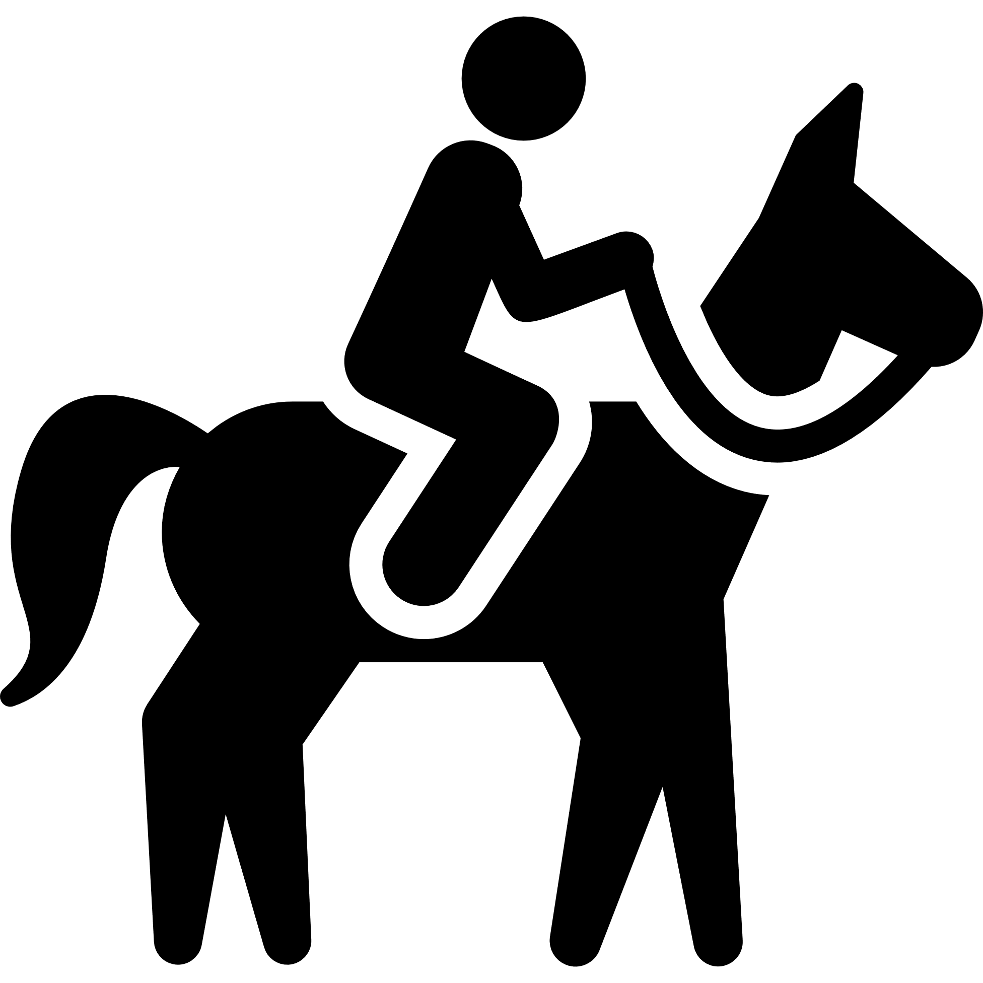
 | ‘Theirs but to do and die’ | theirs
 | ‘a green hedge / That dazzled with rifle fire’ | Green/  dazzled | 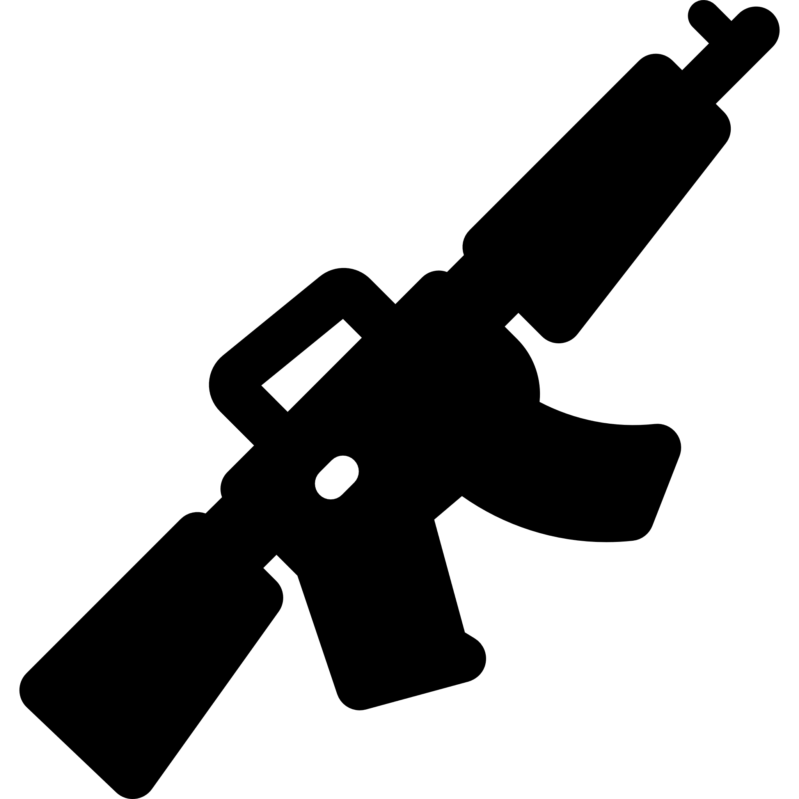
 | ‘The patriotic tear that had brimmed in his eye’ | patriotic | 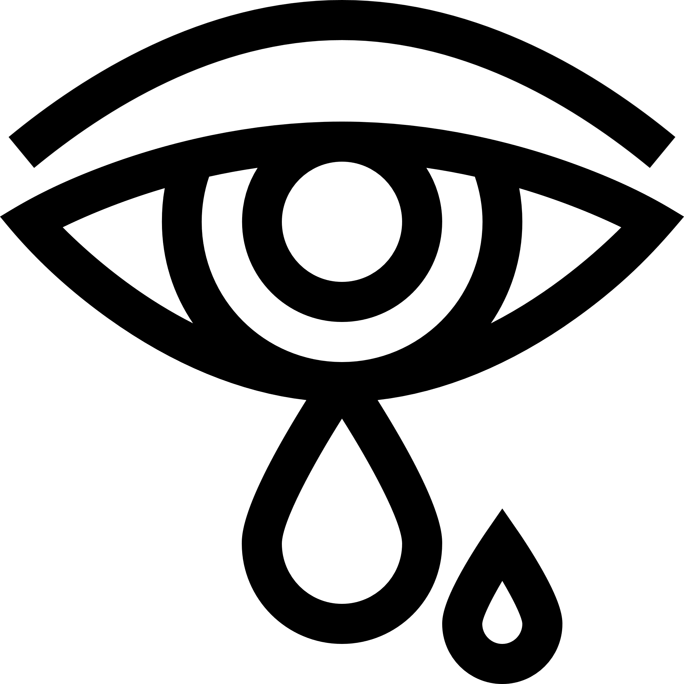
 | “‘His terror’s touchy dynamite’ | dynamite
 | ‘But nothing happens’ | nothing
 | ‘Merciless iced east winds that knive us’ | Merciless
 | ‘Pale flakes with fingering stealth come feeling for our faces’ | stealth

Poem & Poet | Quote | Key Words | Image | Interpretations/significant connotations | Themes | Comparison
 | ‘A hundred agonies in black and white’ | Hundred/  agonies
 | ‘spools of suffering set out in ordered rows’ | Suffering/  ordered
 | ‘All flesh is grass’ | Flesh/ grass | 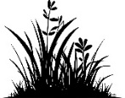
 | “his bloody life in my bloody hands” | bloody
 | And the drink and drugs won’t flush him out’ | flush
 | “Sleep, and he’s probably armed, possibly not” | possibly | 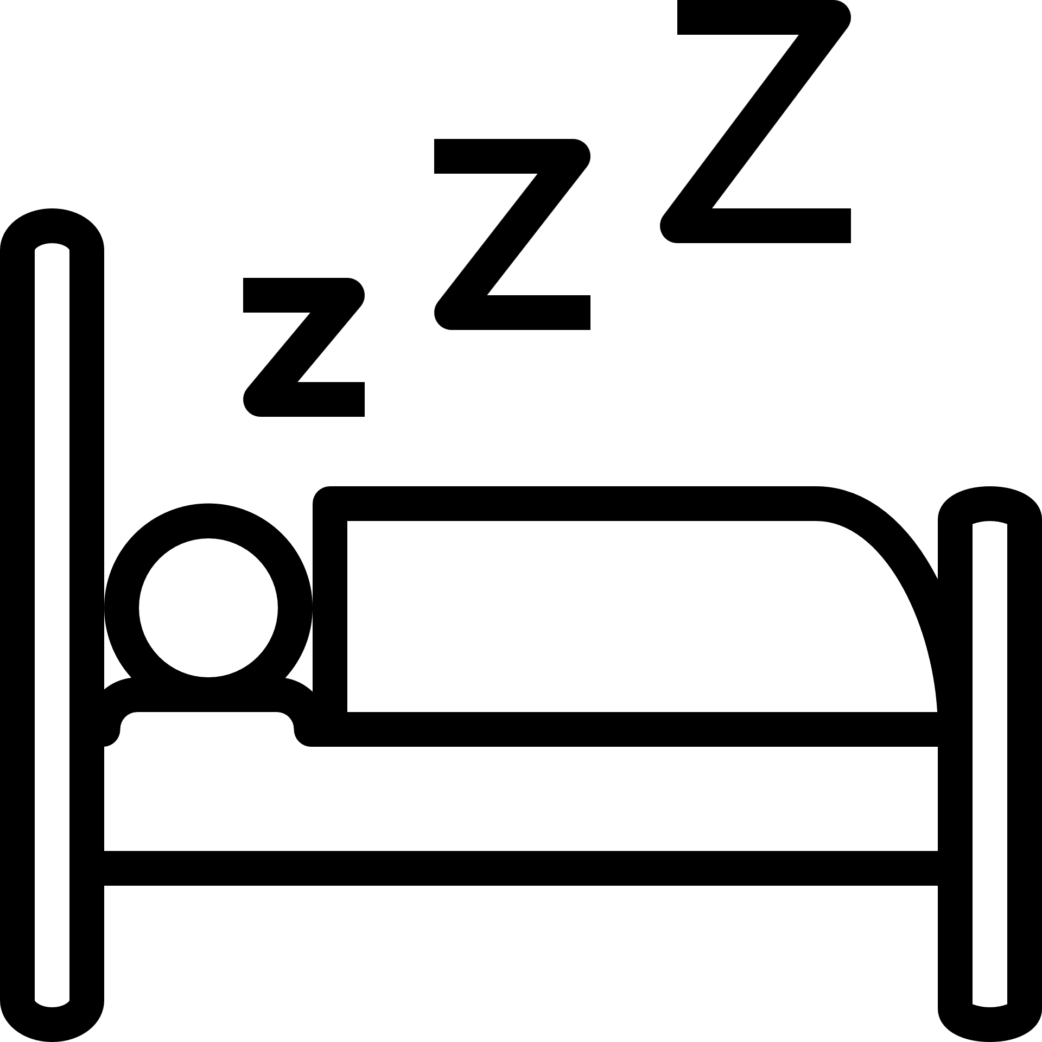
 | “a shaven head full of powerful incantations” | incantations
 | “gradually, we too learned to be silent” | silent
 | “he must have wondered which had been the better way to die” | wondered | 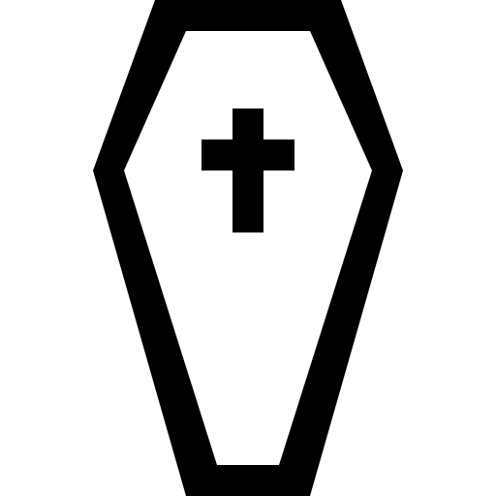
 | “leaned against it like a wishbone” | wishbone
 | “released a songbird from its cage” | Released/  songbird | 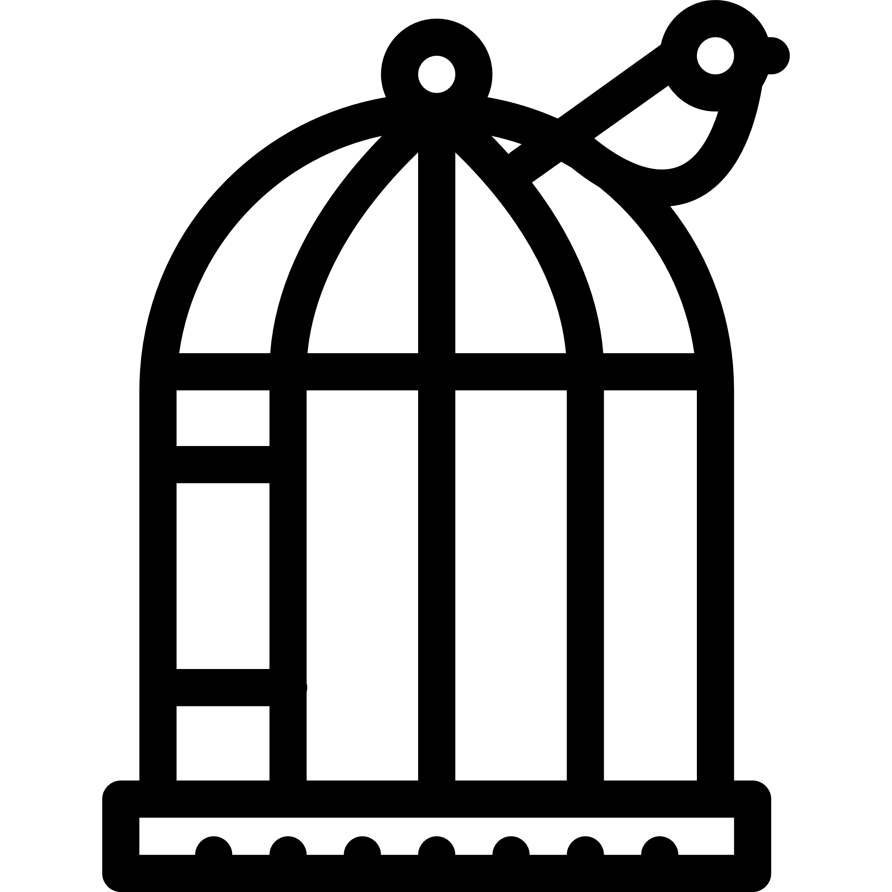
 | “hoping to hear your playground voice” | playground | 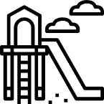
 | “bright, filled paperweight” | bright
 | “My city hides behind me” | My/  hides
 | “I am branded by an impression of sunlight” | Branded/  sunlight

