Poem & Poet | Quote | Key Word | Image | Interpretations/significant connotations | Themes
 | “King of Kings’ | King | 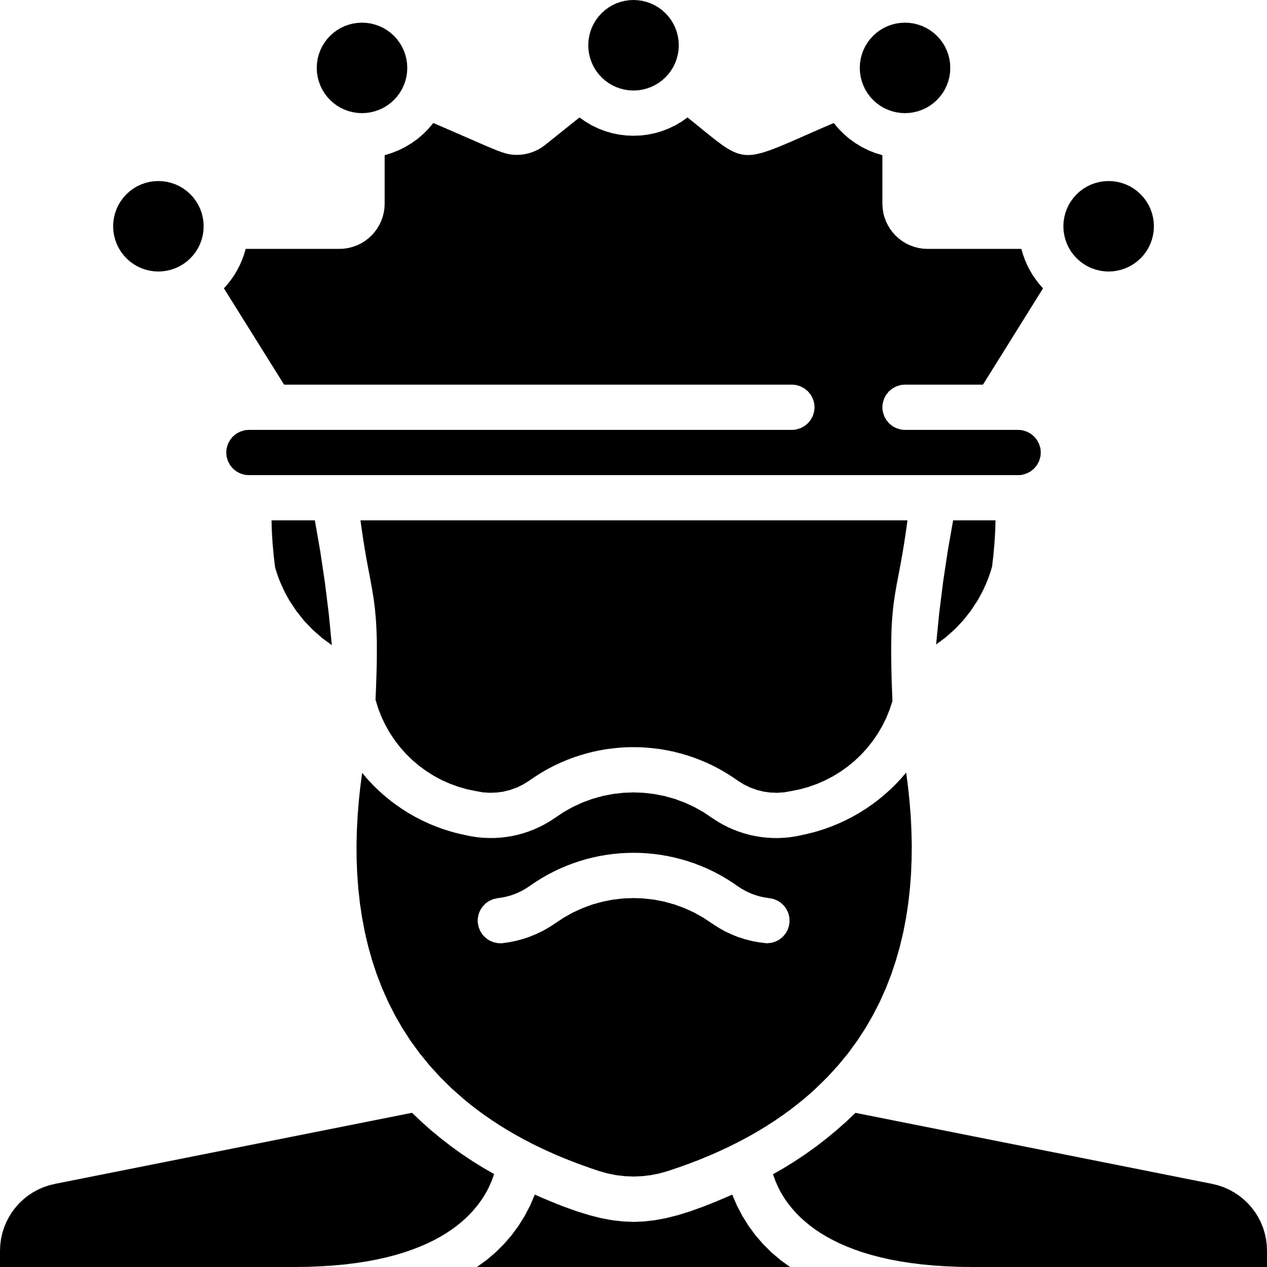
 | ‘A shattered visage lies’ | Shattered
 | ‘The lone and level sands stretch far away’ | Lone | 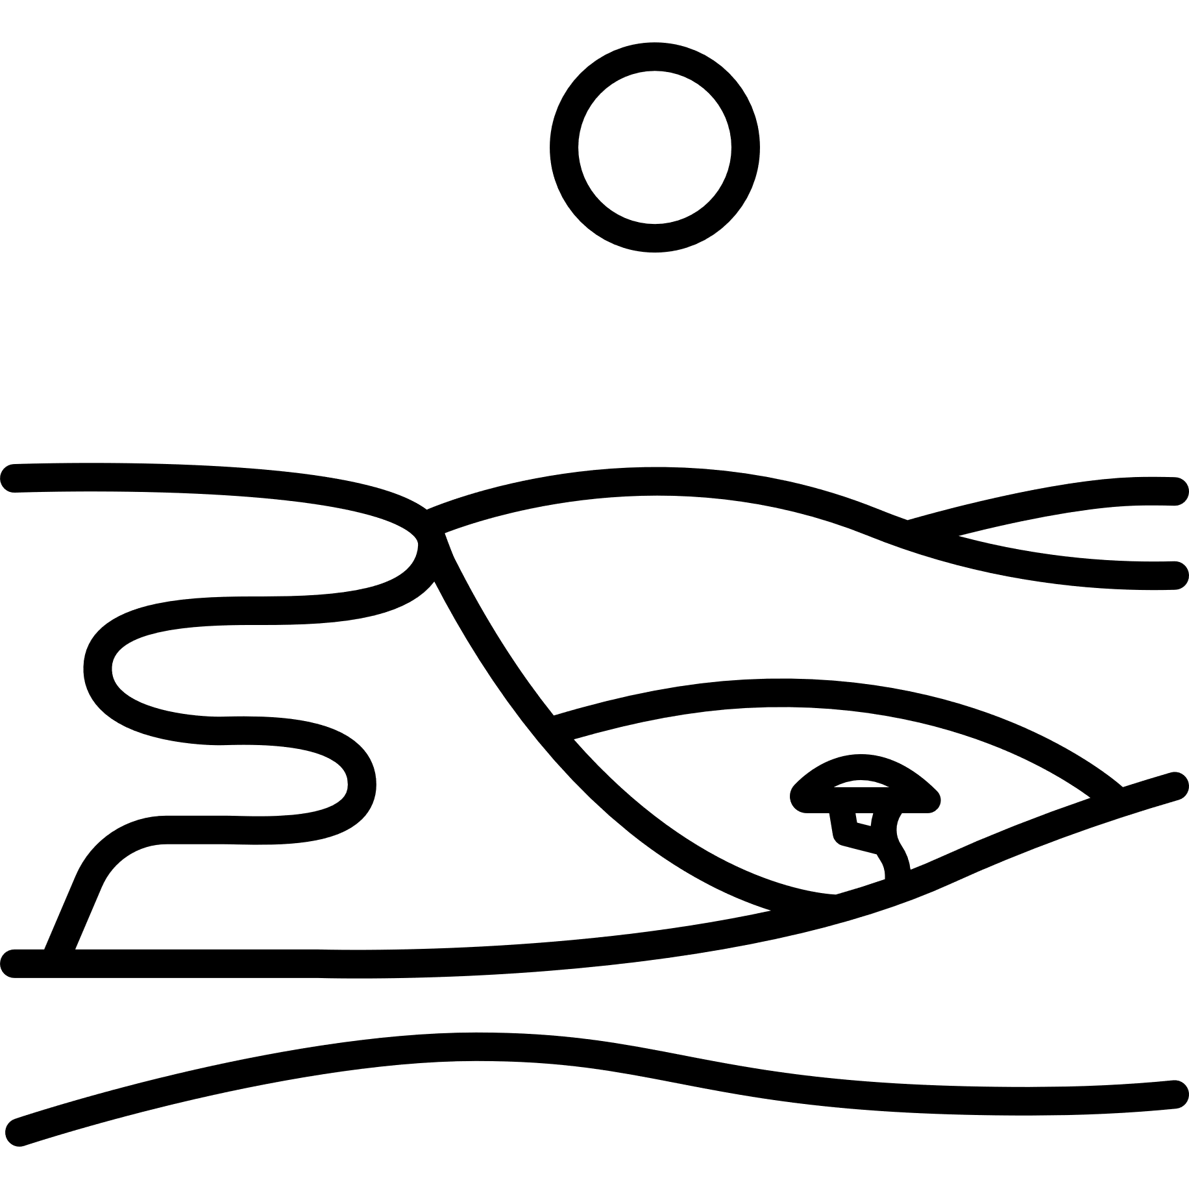
 | “I gave commands then all smiles stopped’ | Commands
 | “As if she ranked my gift of a nine-hundred-year-old-name’ | Gift
 | “Notice Neptune, taming a seahorse’ | Neptune | 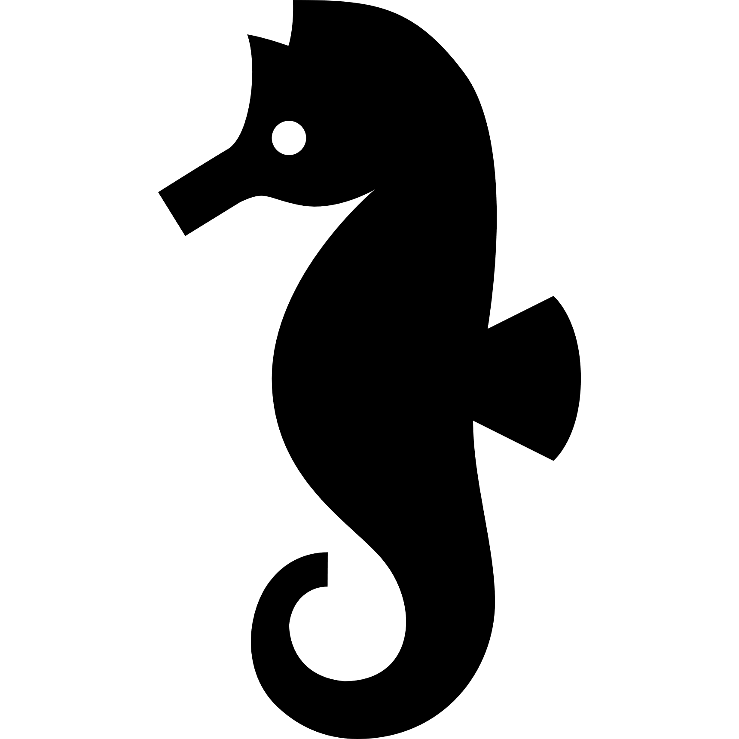
 | “a huge peak, black and huge’ | Huge | 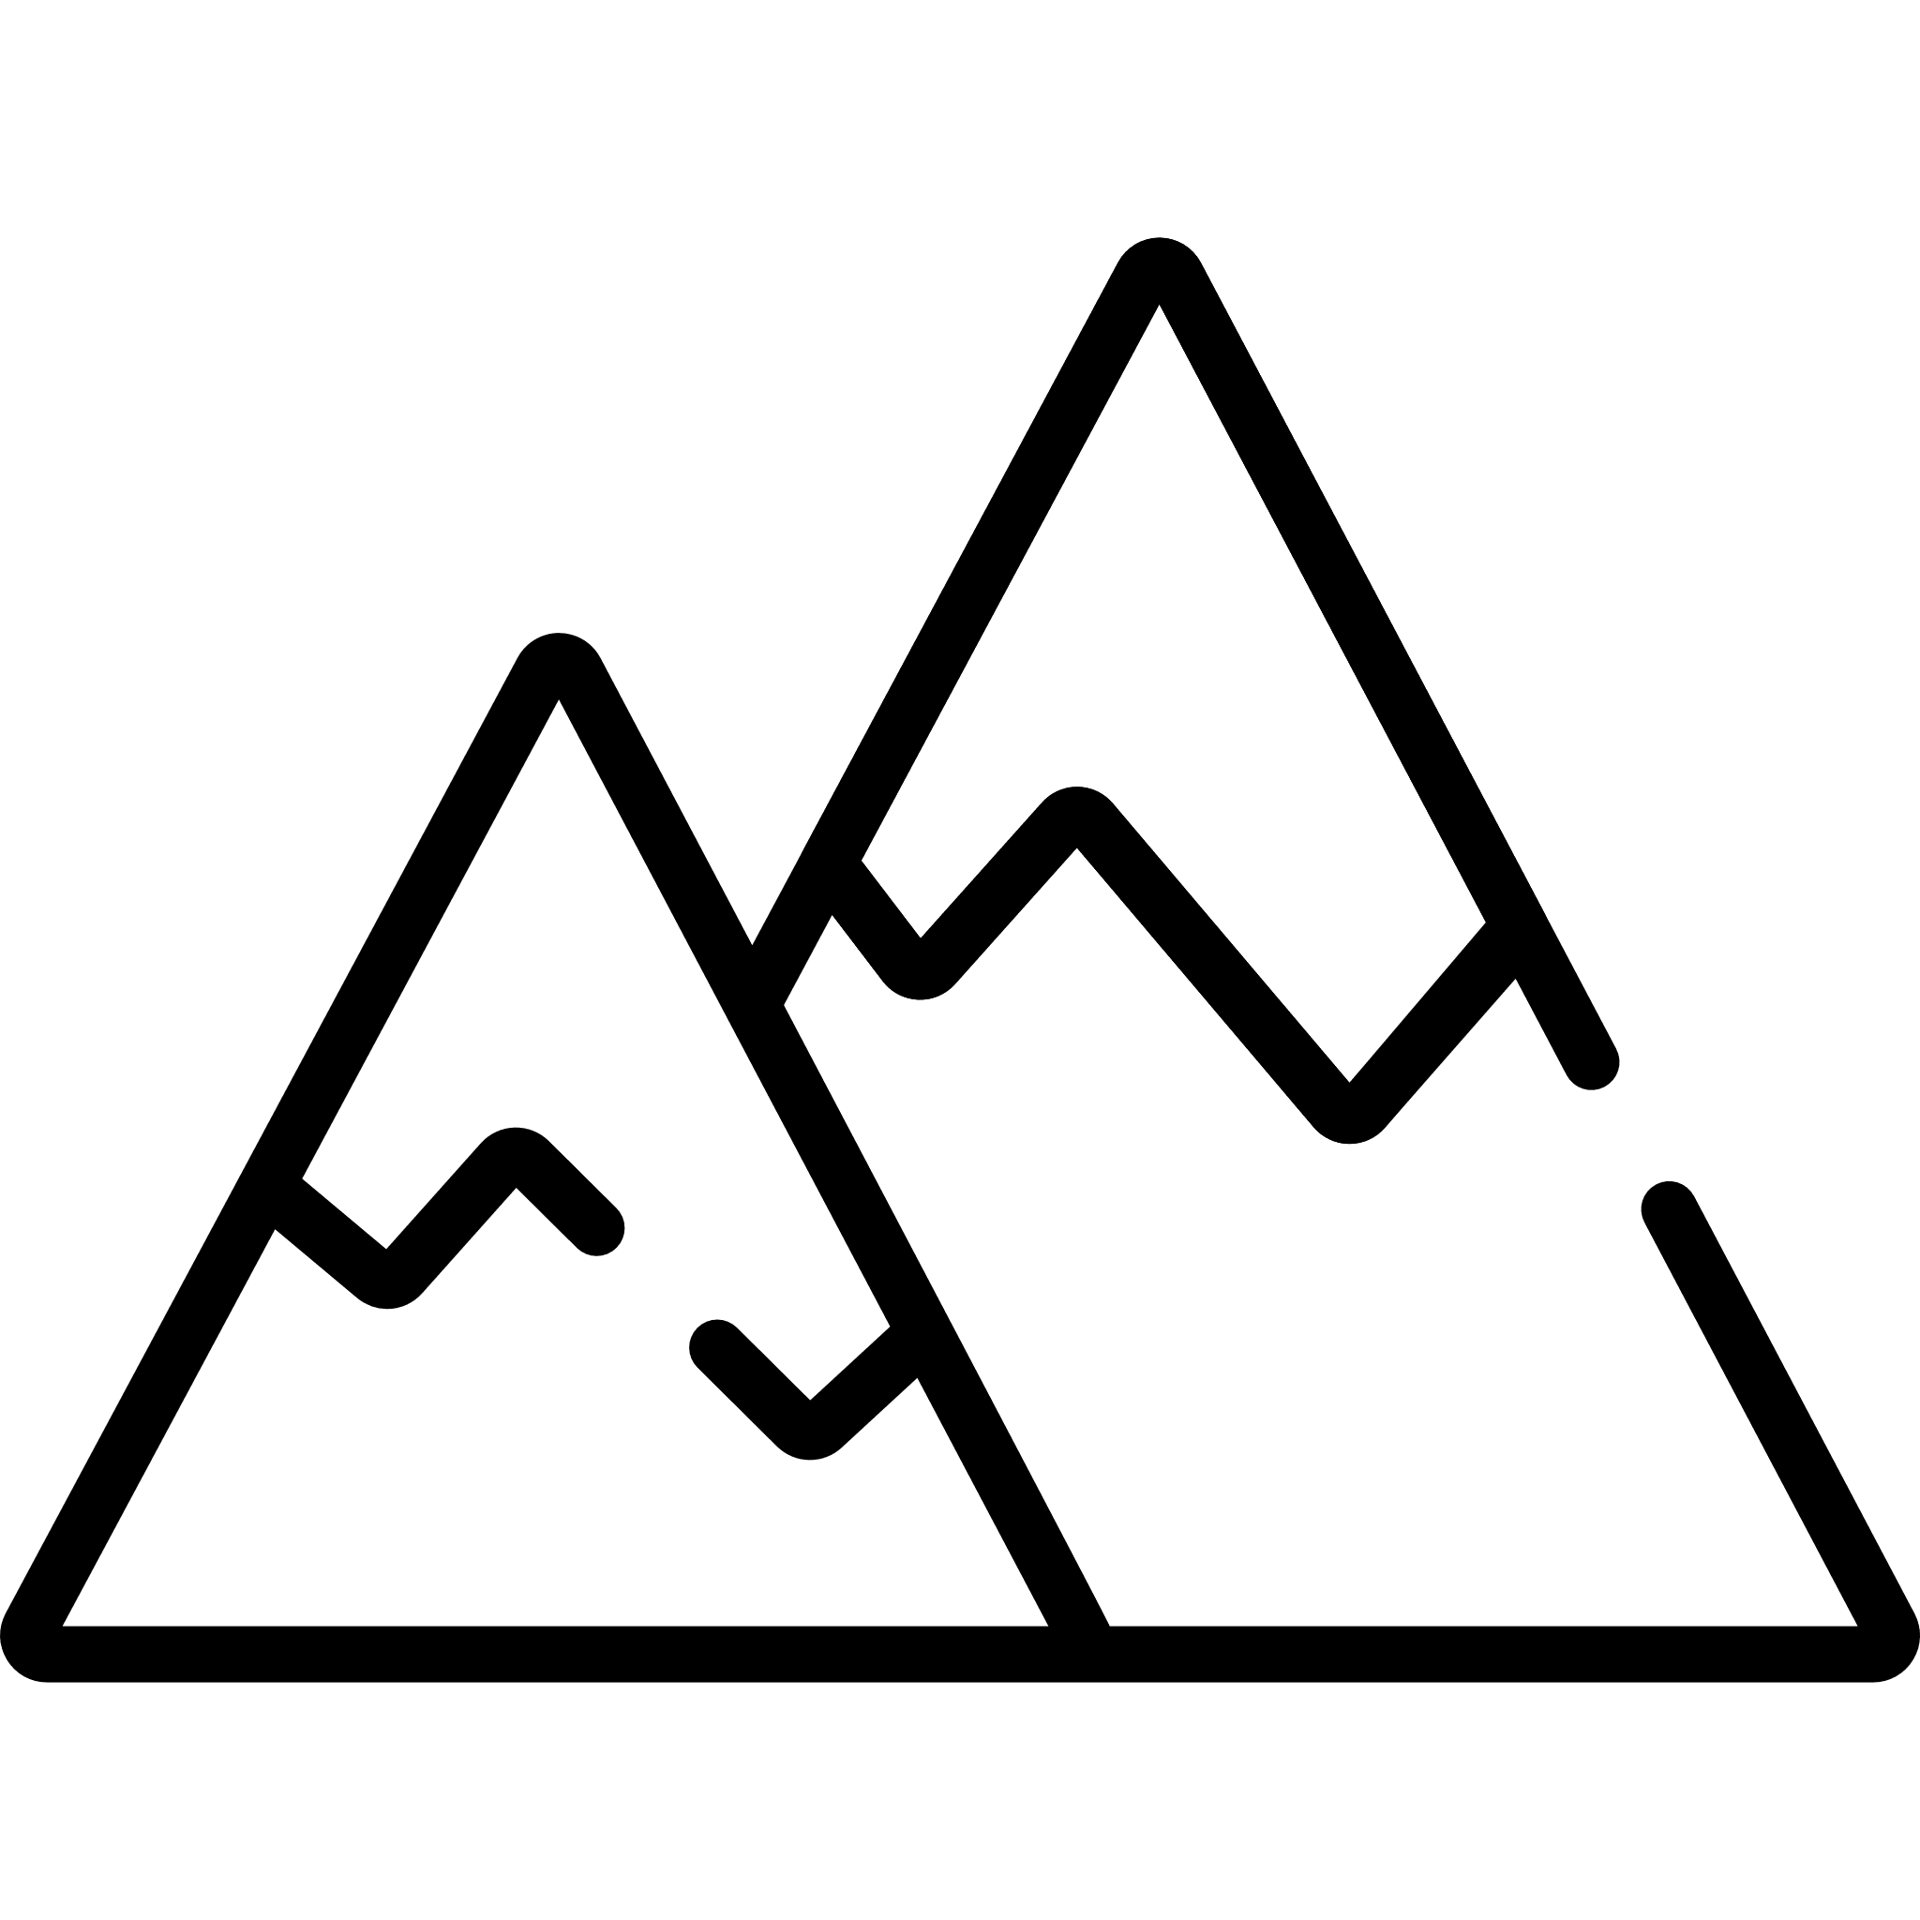
 | ‘huge and mighty forms…were a trouble to my dreams’ | Trouble/ Dreams
 | “proud of his skill’ | Skill | 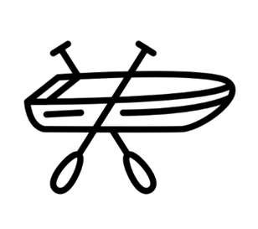
Power & Conflict Set 2 – Power Key Quotes Dual Coded
Poem & Poet | Quote | Key Word | Image | Ideas/explanation | Themes
 | “I carving out my own identity’ | Carving
 | ‘Dem tell me wha dem want to tell me’ | Tell
 | ‘Bandage up me eye […] blind me to me own identity’ | Bandage
 | “mind-forged manacles I hear’ | Manacles | 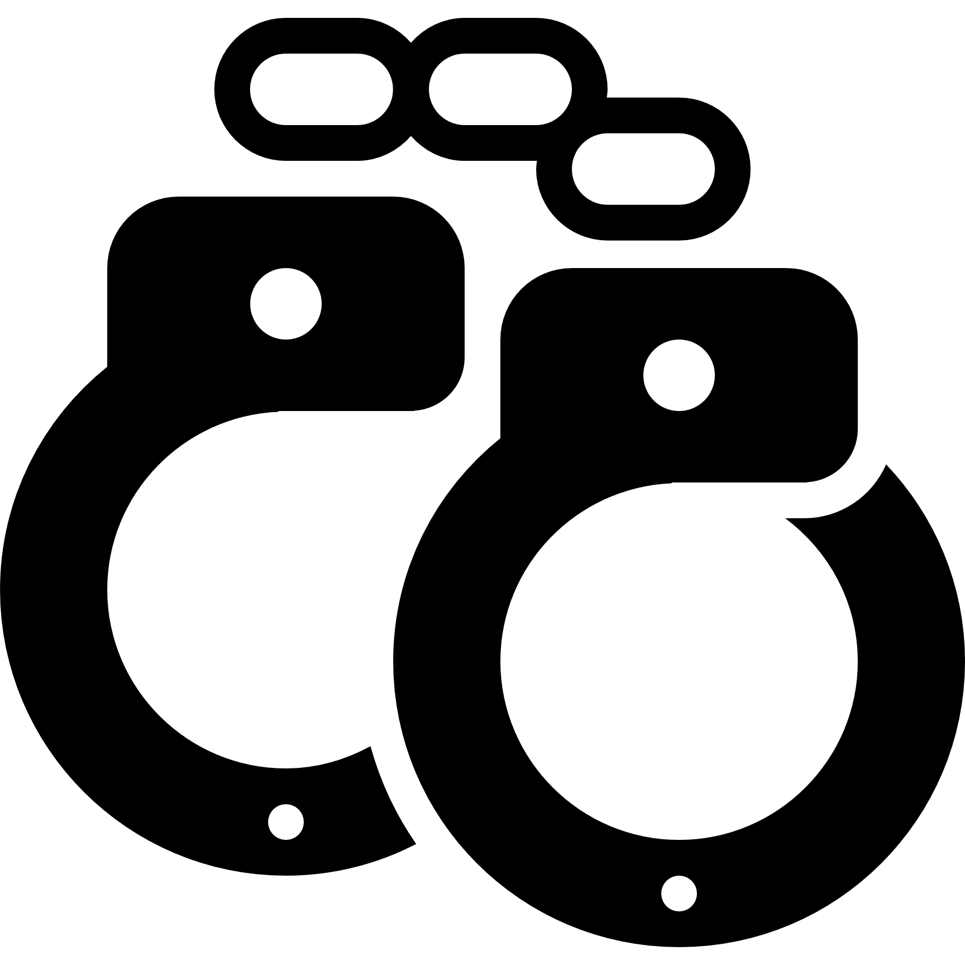
 | “runs in blood down Palace walls’ | Gift
 | “every black’ning Church’ | Church
 | “Let daylight break through’ | Daylight
 | “might fly our lives like paper kites’ | Fly
 | “pages smoothed and stroked and turned/transparent with attention’ | Smoothed
 | ‘We are prepared’ | Prepared
 | ‘spits like a tame cat turned savage’ | Savage | 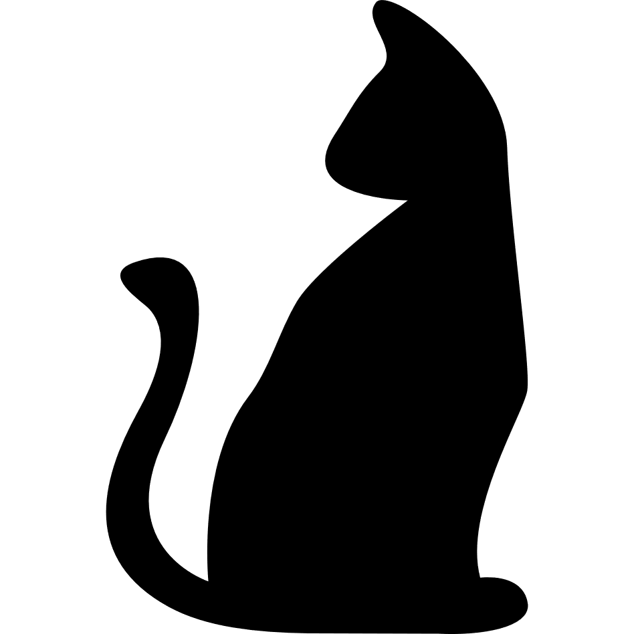
 | It is a huge nothing that we fear’ | Nothing/  Fear

